**WEEK-11 CODING**

1. Problem Description:

Write a Python program that asks the user for their age and prints a message based on the age. Ensure that the program handles cases where the input is not a valid integer.

Input Format

Asingle line input representing the user's age.

Output Format:

Print a message based on the age or an error if the input s invalid.

**PROGRAM:**

try:

a = input()

if int()>=0;

print(“Error: please enter a valid age”)

except:

print(“Error: Please enter a valid age.”)

**OUTPUT:**

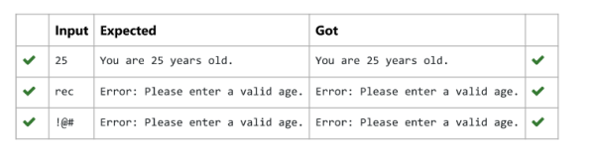

2. Write a Python program that asks the user for their age and prints a message based on the age. Ensure that the program handles cases where the input is not a valid integer.

Input Format: A single line input representing the user's age,

Output Format: Print a message based on the age or an error if the input is invalid.

**PROGRAM:**

try:

a = input()

if int(a) >= 0:

print("You are", a, "years old.")

else:

print("Error: Please enter a valid age.")

except:

print("Error: Please enter a valid age.")

**OUTPUT:**

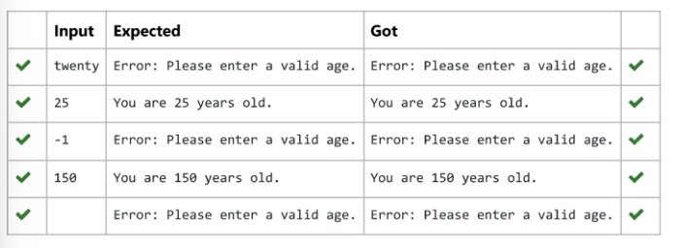

3. Write a Python program that performs division and modulo operations on two numbers provided by the user. Handle division by zero and

non-numeric inputs.

Input Format:

Two lines of input, each containing a number.

Output Format:

Week11_Coding: Attempt review

Print the result of division and modulo operation, or an error message if an exception occurs.

**PROGRAM:**

try:

a = input()

b = input()

c = int(a) / int(b)

d = int(a) % int(b)

except ZeroDivisionError:

print("Error: Cannot divide or modulo by zero.")

except:

print("Error: Non-numeric input provided.")

else:

print("Division result:", c)

print("Modulo result:", d)

**OUTPUT:**

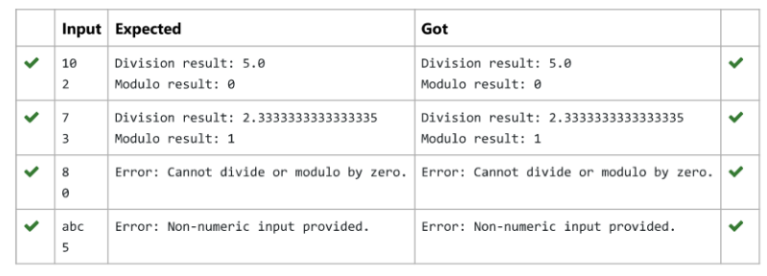

4. Write a Python script that asks the user to enter a number within a specified range (e.g., 1 to 100). Handle exceptions for invalid inputs and

out-of-range numbers.

Input Format:

User inputs a number.

Output Format:

Confirm the input or print an error message if it's invalid or out of range.

**PROGRAM:**

try:

a = input()

if int(a) > 0 and int(a) < 101:

print("Valid input.")

else:

print("Error: Number out of allowed range")

except:

print("Error: invalid literal for int()")

**OUTPUT:**

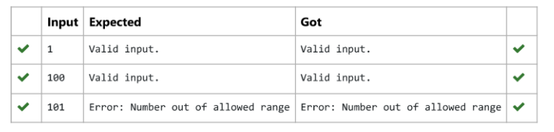

5. Develop a Python program that safely performs division between two numbers provided by the user. Handle exceptions like division by zero and non-numeric inputs.

Input Format: Two lines of input, each containing a number.

Output Format: Print the result of the division or an error message if an exception occurs.

**PROGRAM:**

try:

a = input()

b = input()

c = float(a) / float(b)

except ZeroDivisionError:

print("Error: Cannot divide or modulo by zero.")

except ValueError: # Corrected the exception for non-numeric input

print("Error: Non-numeric input provided.")

else:

print(c)

**OUTPUT:**

